­

SOFTWARE CONSTRUCTION

**QUAID-I-AZAM UNIVERSITY, ISLAMABAD**

SCHOLARSHIP

MANAGEMENT SYSTEM

**SUBMITTED TO**: MAM ONAIZA MAQBOOL

**SUBMITTED BY**:G8

AMNA MUZAFFAR(04072013003)

LAIBA MASOOD(04072013002)

2022

Table of Contents

**1.** **INTRODUCTION** 3

**1.1.** **Purpose of SMS:** 3

**1.2.** **Scope of SMS:** 3

**1.2.1.** **Major Functionalities:** 3

**1.2.2.** **Objectives of SMS:** 3

**1.2.3.** **Project Deliverables:** 3

**1.3.** **Definitions:** 4

**1.4.** **References** 4

**1.5.** **Overview:** 4

**2.** **OVERALL DESCRIPTION:** 4

**2.1.** **Product Perspective:** 4

**2.1.1.** **System Interfaces:** 4

**2.1.2.** **User Interfaces:** 4

**2.1.3.** **Hardware Interfaces:** 5

**2.1.4.** **Software Interfaces:** 5

**2.1.5.** **Communication Interfaces:** 5

**2.1.6.** **Memory Constraints:** 5

**2.1.7.** **Operations:** 5

**2.2.** **Product Functions:** 5

**2.3.** **User Characteristics:** 5

**2.4.** **Product Constraints:** 6

**2.5.** **Assumptions and dependencies:** 6

**2.6.** **Apportioning of requirements:** 6

**4.** **Supporting Information:** 13

**4.1.** **Appendix** 13

**DOMAIN MODEL:** 13

**USE CASE DIAGRAM:** 14

**SYSTEM SEQUENCE DIAGRAM FOR APPLCATION FORM FIILING:** 15

**SYSTEM SEQUENCE DIAGRAM of INFORMING STUDENTS:** 16

# **INTRODUCTION**

* 1. **Purpose of SMS:**

Main purpose of Scholarship Management System(SMS) is to reduce Man workload and to automate entire scholarship process(from applying of students to their selection and maintaining their records).

## **Scope of SMS:**

### **Major Functionalities:**

* + - Maintaining Students, scholarships, and their sponsors details
    - Publishing Need/Merit Based or Program based scholarships
    - Selections of Students by System itself based on the criteria set
    - Advertisements about different scholarships offered to Students related to their program and field
    - Login facility to Students to access their information, fill Application Form in their portal, view their scholarship selection status and submit complaint against any query/error in their application form or scholarship selection status.
    - Login Facility to Admin to maintain records of all scholarships, view student and scholarship details, provide feedback to student complaints and timely inform students about their selection
    - Admin can view details of different students and scholarships
    - Admin modifying and deleting existing scholarships and sponsors
    1. **Objectives of SMS:**
* Due to Automatic selection of students by the system itself rather than doing it manually will reduce time consumption and will reduce the delay causes due to human errors
* Reduce man workload
* Students will get to know about latest scholarships timely.
* Students will easily access their scholarship status and other details on their portal.
* Minimize amount of paperwork required by filling the application forms online
* Scholarship section will be able to maintain their records in more effective and efficient way as problems of redundancy will be removed, searching and generation of reports will become easy.

### **Project Deliverables:**

* Host DBMS
* Report Generator
* Web Application
* Documentation

## **Definitions:**

*Table 1:Definitions*

|  |  |
| --- | --- |
| **Terms** | **Descriptions** |
| **SMS** | Scholarship Management System |
| **Client/User** | Instructor Of Our Course Software Construction |
| **UCMS** | University Campus Management System: Database System containing all the information of university |
| **SRS** | Software Requirement Specifications: Description of software to be developed |
| **QAU** | Quaid-i-Azam University, Islamabad |
| **ISO/IEC/IEEE** | IEEE Recommended Practice for Software Requirements Specifications |
| **DBMS** | Database Management System |
| **PDF** | Portable Document Format |
| **PNG** | Portable Network graphics |
| **Admin** | Technical Employee of QAU in Financial Aid Office |

## **References**

1. ISO/IEC/IEEE 16326:2019

## **Overview:**

The remainder of SRS is organized as follow: Section 2 describes overall description of SMS including product perspective, product functions, user characteristic) Section 3 is most important part of SRS as it is describing specific functional requirements of SRS ,also non-functional requirements including performance requirements and software system attributes.

# **OVERALL DESCRIPTION:**

## **Product Perspective:**

SMS(Scholarship Management System) is not stand-alone system and being a part of UCMS(University Campus Management System). It will retrieve information from UCMS. For example, when student/admin logins to SMS, it will be verified by UCMS also in application filling of form by student some entities are retrieved from UCMS.

### **System Interfaces:**

Not applicable.

### **User Interfaces:**

GUI will be used to make the interface pleasing, confusion free and user friendly. Help sections and FAQs will be provided with every functionality for ease of use. Buttons, checkboxes, textboxes, and combo boxes will be used to allow easy filling of application form.

### **Hardware Interfaces:**

Not Applicable.

### **Software Interfaces:**

SMS software has following interfaces:

1. UCMS(University Management System).
2. MySQL Server
3. Web Browser Visual Studio Code

### **Communication Interfaces:**

Not Applicable.

### **Memory Constraints:**

Not Applicable.

### **Operations:**

Not Applicable.

* + 1. **External Interfaces:**

**User (Student/Admin) Login:**

Details of input for login are following:

1. **User-ID**

* Name of Item: User ID
* Description of Purpose: To verify if user is enrolled in university and allows him to access his data
* Source of Input: Text provided through keyboard
* Valid range, accuracy, and tolerance: 11 digits
* Units of measure: no units
* Relationships to other inputs: provided password along with ID must be matched to credentials saved at backend. Verification from UCMS provides further inputs like Department, Current semester, GPA etc.
* Screen: login interface
* End Message: On correct ID: login completed successfully. On incorrect ID: allow incorrect entry 5 times then disable input box for 15 minutes.

1. **Password**

* Name of Item: Password
* Description of Purpose: For data security and privacy
* Source of Input: Text provided through keyboard
* Valid range, accuracy, and tolerance: 8 characters minimum. Upper- and lower-case letters, at least 1 special character and numeric characters
* Units of measure: no units
* Relationships to other inputs: ID and password interlinked, cannot be verified without each other.
* Screen: login interface
* End Message: On correct password: login successful. On incorrect password: display Forgotten Password? Message to display solutions to access it back ( Reset for Admin using Security Question, contact department to gain access for student)

## **Product Functions:**

* **Student Side:**

1. View Scholarship Selection Status
2. Apply for Scholarship
3. View Personal Details
4. View various Scholarships offered
5. Accept/ Reject scholarship
6. Register complaint

* **Admin Side:**

1. View details of eligible, ineligible students, scholarships and their sponsors.
2. Inform students about their selection
3. Provide feedback to students about any errors or questions
4. Generate reports of annual or semester wise consumption of funds, number of scholarships offered, number of applicants, eligible and selected students.
5. Add ,update and delete scholarship details
6. Add ,update and delete sponsors details

## **User Characteristics:**

**Student:**

Students accessing the application can belong to age groups 18-35, or programs BS, MS, MPhil, or PhD. They can have beginner to professional level technical knowledge. To provide ease of use and ease of recovery from errors, more non-technical terms are used. Training beforehand is not needed. Help is provided along the steps of filling an application form. Tutorials may also be uploaded to guide about the system functionalities. Students at the University can only access SMS through their Registration Numbers and passwords provided to them for their CMS. Login credentials are provided by university and cannot be reset. University should be contacted in case of loss of credentials.

**Admin:**

Only administrator and his/her assistants can access, modify, delete or update information on the scholarship management system. It is necessary for admin to be part of university and have a faculty ID verified from the CMS. ID will be set once but resetting of password will be allowed after answering a security question. The admin will need technical expertise to manage the SMS thus he must be a professional. Trainings shall be provided to the admin and his team regarding the system beforehand.

## **Product Constraints:**

1. A student can avail only one scholarship at one time and is ineligible to apply for others.
2. If a student gets accepted to more than 1 scholarships, he/she will have the right to accept whichever one he wants to avail and reject the others
3. If a student does not respond to the scholarship before the deadline assigned, he will lose the chance to avail it.
4. Student is not able to change the entities auto filled in application form, also he is not allowed to change his profile, he can only view his profile.
5. Admin is not allowed to select students for scholarship according to his interest. List should be generated automatically on basis of defined criteria.

## **Assumptions and dependencies:**

* + 1. Admin may modify the list of selected students before sending an informing email.
    2. Interview dates for students can be generated automatically by the system and send via email.
    3. System will be compatible with all browsers. Mozilla Firefox will be preferred for data security.
    4. System may be accessible only through University's Intranet
    5. When a scholarship is outdated, admin will delete the scholarship. It will also delete the sponsors linked to it. However, it will remain saved in the backup for 5 years then automatically deleted

## **Apportioning of requirements:**

Not Applicable.

1. **SPECIFIC REQUIREMENTS:**
   1. **Functional Requirements:**
      1. **Authorization of Student and Admin:**
2. **System must check whether Student/Admin has entered his correct user-id and password.**

* *Input:*

Student**/**Admin enter his user-id and password.

* *Processing:*

Check if it is valid for this it will send the data to UCMS for verification and receive response from UCMS.

* *Output:*

Accept or reject authorization from UCMS.

1. **Different answers from UCMS about authorization.**

* *Input:*

Response from UCMS

* Wrong password/Invalid Password(If password is incorrect)
* Wrong User-Id/Invalid User-Id(If password is incorrect)
* *Processing:*

If System receives any of these responses from UCMS, login will be failed and student will get an error message.

* *Output:*

login failed and an error message will be displayed on Portal.

1. **If User-Id and Password are correct, authorization process is finished.**

* *Input:*

System gets accept from UCMS from authorization process.

* *Processing:*

Finishing authorization.

* *Output:*

Opens Student**/**Admin portal on Screen.

1. **If login failed more than 3 times in a row ,a message will be displayed that your account is temporarily blocked please contact your respective administration.**

* *Input:*

Entering wrong user-id and password for 4th time in succession.

* *Processing:*

Initiate authorization process and message from UCMS to block account.

* *Output:*

display error message that the student should contact University administration.

Display methods to reset password for admin

* + 1. **Other Functional Requirements:**

1. **Student can only view his profile in his portal and is unable to modify it.**

* *Input:*

Students view their profile and try to change it

* *Processing:*

UCMS will not allow him to do this.

* *Output:*

There’s no option to modify information and it remains same on portal.

1. **Student can check their scholarship status(Selected, pending, rejected).**

* *Input:*

Students view their scholarship status on portal.

* *Processing:*

Website will retrieve information from system database and display status.

* *Output:*

Displays status to Student.

1. **Student can view scholarships advertised on their portal which are related to their field and program.**

* *Input:*

students view scholarships advertised.

* *Processing:*

Website will retrieve advertised scholarships from database of System.

* *Output:*

Display Scholarships to Student.

1. **If Student is selected in one or more scholarships, System will show options to accept or reject it.**

* *Input:*

Website will present options to students to accept or reject scholarship.

* *Processing:*

Student will select one option and it will be updated in system database.

* *Output:*

Status of Scholarship updated on portal of student as well as in system database.

1. **If Student is facing any problem and have issues, he can make a complaint about it.**

* *Input:*

Student will make a complaint on his portal(Complain name, type, Description, picture(optional))

* *Processing:*

Complaint will be sent to admin portal.

* *Output:*

Message will be displayed that complaint is registered successfully.

1. **Students will receive feedback about the complaint they registered.**

* *Input:*

Admin will respond to the complaint within 24 hours.

* *Processing:*

System will update this feedback on student portal.

* *Output:*

Student will see feedback on his portal within 24 hours of making a complaint.

1. **If student is currently availing scholarships, he will not be able to apply for other scholarships advertised on his portal.**

* *Input:*

Set student scholarship status in system database to active and then login to verify.

* *Processing:*

System will open portal and show advertised scholarships but disabled apply options.

* *Output:*

Student will be unable to apply for it and will be ineligible.

1. **Students apply for scholarship by filling application form.**

* *Input:*

Student select scholarship in which he wants to apply.

* *Processing:*

System will present application form with some entitles auto filled(Name, Father Name, Registration Number, Program, CGPA).

* *Output:*

Application form with remaining entities to be filled.

1. **Student must fill remaining entities in valid format.**

* *Input:*

Fill remaining entities(Current semester, father cnic, father occupation, monthly income, no of siblings, monthly utility bills charges, house details, any property own).

* *Processing:*

System will check format and if it is invalid not accept it.

* *Output:*

Message will be displayed that invalid format with valid format as an example.

1. **If Student enters information in invalid format, system will not accept it.**

* *Input:*

Fill entity in invalid format like CNIC in invalid format.

* *Processing:*

System will check format and if it is invalid not accept it.

* *Output:*

Message will be displayed that invalid format with valid format as an example.

1. **After successful filling of all entities, student will upload all required documents.**

* *Input:*

Student will upload documents listed(Student CNIC, Father CNIC, Transcript, Father Income Certificate, Last 6 months utility bills, family certificate).

* *Processing:*

System will check format and if it is in valid format accept it and mark the check list.

* *Output:*

Student is then able to submit the application form.

1. **If Student uploads documents other than pdf and .png format, system will not accept it.**

* *Input:*

Student will Upload document in another format.

* *Processing:*

System will check format and if it is invalid not accept it.

* *Output:*

Message will be displayed that invalid format with valid format as an example.

1. **After submission of application form by student, system should allocate applicant id to student and update his scholarship status to pending.**

* *Input:*

Student will submit the form.

* *Processing:*

System will update records in database and allocate applicant it and update scholarship status.

* *Output:*

Student will receive applicant id and having a pending status on his portal.

1. **Admin can view list of eligible students, ineligible students, sponsors and scholarships.**

* *Input:*

Admin opens his portal and view lists.

* *Processing:*

System will retrieve these lists from database.

* *Output:*

Admin will view this on his portal.

1. **Admin can view list of eligible students, ineligible students, sponsors and scholarships.**

* *Input:*

Admin opens his portal and view lists.

* *Processing:*

System will retrieve these lists from database.

* *Output:*

Admin will view this on his portal.

1. **Admin can inform students about their selection by sending them email with interview date and update their scholarship status on their portal.**

* *Input:*

Admin view selected students’ details and selects option on his portal to inform them.

* *Processing:*

System will generate emails with interview date and send them to students email addresses. Also ,System updates status of scholarship to Active on Student portal. .

* *Output:*

Message will be displayed on Admin portal that students are informed successfully.

1. **Admin can send feedback to students about their complaints.**

* *Input:*

Complaints from Student portal are displayed on Admin Portal and Admin respond to them.

* *Processing:*

System will send these feedbacks to respective student’s portal.

* *Output:*

Mark tick against these complaints that these are registered successfully.

1. **Admin can generate different reports according to their need(Annual/Semester Wise Consumption of Funds, List of Applicants, List of Selected Students).**

* *Input:*

Admin will select option from his portal to generate report.

* *Processing:*

System will retrieve these lists from database.

* *Output:*

Admin can view these reports and can download them.

1. **Admin can publish new scholarship by filling a form on his portal that will be then advertised on Student’s portal.**

* *Input:*

Admin filles required entities in form(Scholarship Name, scholarship Type, Description, Sponsors, number of students allowed to avail, email, phone no, year offered in, eligibility requirements).

* *Processing:*

System will save these records in database and then advertised these scholarships on student’s portal related to their field and program.

* *Output:*

Message will be displayed that Scholarship is advertised successfully.

1. **Admin can add, delete and update records of scholarships and sponsors.**

* *Input:*

Admin will select option to add, delete and update.

* *Processing:*

System will perform these actions and updated records in System database.

* *Output:*

Message about successful operation.

1. **Admin can set criteria about the selection of students and system has to generate list of students falling in these criteria automatically and admin is unable to modify it.**

* *Input:*

Admin will set criteria about specific scholarship on his portal.

* *Processing:*

System will then retrieve students falling under this automatically from database and presents a list.

* *Output:*

Admin will come up with list of selected students that is read-only.

* 1. **Performance requirements:**

1. Error Message should be displayed within 20 seconds.
2. If there no response from UCMS after the request within 2 minutes ,login should be failed, and error message should be displayed.
3. Number of Students can access their portals at the same time.
4. Applicant Id is provided to student if and only if application form is successfully submitted and stores in database records.
5. If any error occurs during filling of application form or publish scholarship form, system should save the contexts till last point and on reload filled them automatically.
6. Selection of students should be done by system after 2 days of deadline of Submission of Application Forms.
7. System should generate alert to Admin Side to inform students within 10 days.
   1. **Software System attributes:**

* **Availability:**

System is available 24/7 to Students and Admin.

* **Security:**

Only registered students and Admin can access our system by their login id and password.

* **Maintainability:**

Only UCMS is allowed to add new students and admins who will use this system further.

* **Recoverability:**

All records for SMS will be recoverable from the backup database. Backup will be performed every 6 months at 2am or as scheduled by admin.

# **Supporting Information:**

# **Appendix**

### **DOMAIN MODEL:**

# 

### **USE CASE DIAGRAM:**

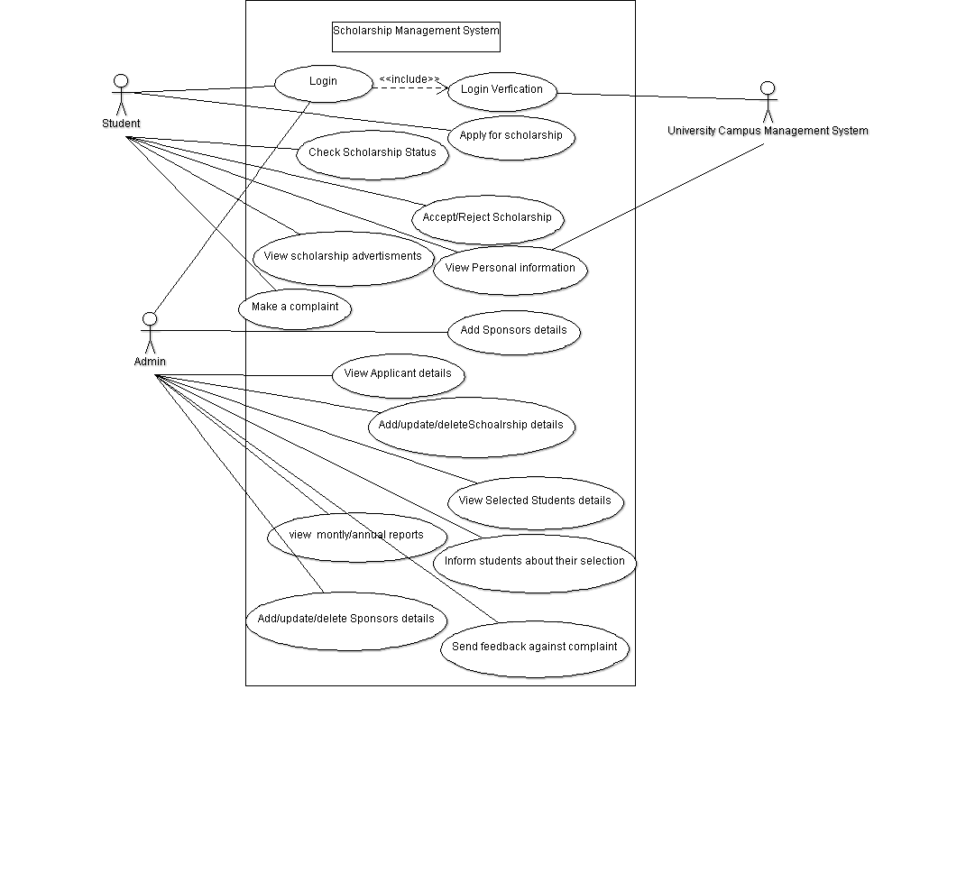

### **SYSTEM SEQUENCE DIAGRAM FOR APPLCATION FORM FIILING:**

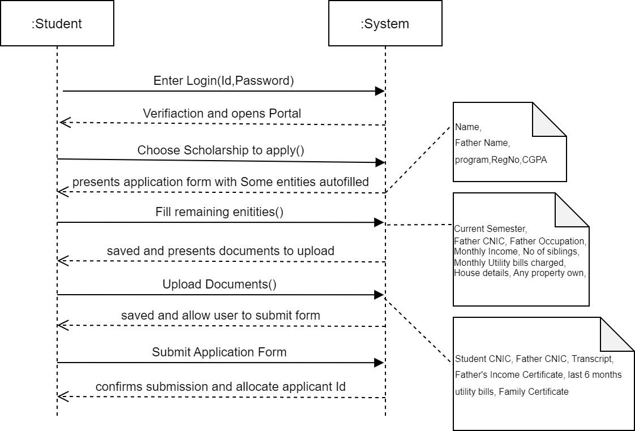

### **SYSTEM SEQUENCE DIAGRAM of INFORMING STUDENTS:**

